Board of Directors 2018-19 Rosters

Name | Company Name | Address | Phone | Email
Gerhard Bendl | Custom Shirts of La Jolla/Bendl’s | 7872 Girard Ave | 858-459-6147 | gerhardbendl@att.net  customshirtsLJ@sbcglobal.net
Laurnie Durisoe | Pantai Inn | 1003 Coast Boulevard | 619-861-1417 | Laurnie@Durisoe.com
Gabriela Guevara | Blue Apparel | 1237 Prospect St. | 508-332-9947 | blueapparel@gmail.com
Michael Dorvillier | Symbio Financial | 7777 Fay Ave Suite, 315 | 858-551-8701 | Michael.Dorvillier@gmail.com
Amelia Hollow | Pure Spectrum CBD | 7863 Girard Ave, Suite 102 | 858-964-8355 | amelia@purespectrumcbd.com
Robert Mackey | La Jolla Golf Carts | 7512 La Jolla Blvd | 619-261-7000 | rm@lajollagolfcarts.com  rm@emailnetworks.com
Kelli Metcalf, Treasurer | Granite Escrow | 1200 Prospect St., Suite 575 | 858-780-6255 |  | kmetcalf@graniteescrow.com  kellisuemetcalf@gmail.com
Brett Murphy, President | La Jolla Sports Club | 7825 Fay Ave, Suite 160 | 858-500-2594 | brett.murphy@lajollasportsclub.com
Don Parks, Vice President | La Jolla Light | 565 Pearl Street, Suite 300 | 858-875-5954 | donp@rsfreview.com
Benoit Roux | Trianon Clothing & Lingerie | 7854 Girard Ave | 619-228-6506 | benoit@stellapacifico.com
Max Shenk | San Diego Fly Rides | 7444 Girard Ave | 619-888-3878 | max@sandiegoflyrides.com
Tammy Tillack | National Geographic Fine Art | 1209 Prospect St. | 619-568-6790  619-808-5255 |  | ttillack@natgeofineart.com
Jessica Wiley | iAM Physical Therapy | 7590 Fay Avenue Suite 403 | 858-224-3387 | info@iamphysicaltherapy.com
Kipp Williams | Blanchard, Krasner & French | 800 Silverado Street | 858-551-2440 | kwilliams@bkflaw.com
Julie Wright, Secretary | (W)right On Communications | 1200 Prospect St. Suite G100 | 760-419-4664 | jwright@wrightoncomm.com

Board of Directors 2018-19 Rosters

Name | Company Name | Address | Phone | Email
Gerhard Bendl | Custom Shirts of La Jolla/Bendl’s | 7872 Girard Ave | 858-459-6147 | gerhardbendl@att.net  customshirtsLJ@sbcglobal.net
Laurnie Durisoe | Pantai Inn | 1003 Coast Boulevard | 619-861-1417 | Laurnie@Durisoe.com
Gabriela Guevara | Blue Apparel | 1237 Prospect St. | 508-332-9947 | blueapparel@gmail.com
Michael Dorvillier | Symbio Financial | 7777 Fay Ave Suite, 315 | 858-551-8701 | Michael.Dorvillier@gmail.com
Amelia Hollow | Pure Spectrum CBD | 7863 Girard Ave, Suite 102 | 858-964-8355 | amelia@purespectrumcbd.com
Robert Mackey | La Jolla Golf Carts | 7512 La Jolla Blvd | 619-261-7000 | rm@lajollagolfcarts.com  rm@emailnetworks.com
Kelli Metcalf, Treasurer | Granite Escrow | 1200 Prospect St., Suite 575 | 858-780-6255 |  | kmetcalf@graniteescrow.com  kellisuemetcalf@gmail.com
Brett Murphy, President | La Jolla Sports Club | 7825 Fay Ave, Suite 160 | 858-500-2594 | brett.murphy@lajollasportsclub.com
Don Parks, Vice President | La Jolla Light | 565 Pearl Street, Suite 300 | 858-875-5954 | donp@rsfreview.com
Benoit Roux | Trianon Clothing & Lingerie | 7854 Girard Ave | 619-228-6506 | benoit@stellapacifico.com
Max Shenk | San Diego Fly Rides | 7444 Girard Ave | 619-888-3878 | max@sandiegoflyrides.com
Tammy Tillack | National Geographic Fine Art | 1209 Prospect St. | 619-568-6790  619-808-5255 |  | ttillack@natgeofineart.com
Jessica Wiley | iAM Physical Therapy | 7590 Fay Avenue Suite 403 | 858-224-3387 | info@iamphysicaltherapy.com
Kipp Williams | Blanchard, Krasner & French | 800 Silverado Street | 858-551-2440 | kwilliams@bkflaw.com
Julie Wright, Secretary | (W)right On Communications | 1200 Prospect St. Suite G100 | 760-419-4664 | jwright@wrightoncomm.com

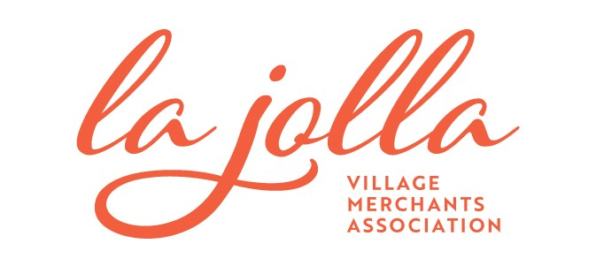
Executive Director: Jodi Rudick | jodi@lajollabythesea.com | 858-230- 2725 | www.lajollabythesea.com
Office Hours: Monday – Friday | 10:00 AM – 6:30 PM

2018-19 Board of Directors

Brett Murphy, President
La Jolla Sports Club

Don Parks, Vice President
La Jolla Light

Kelli Metcalf, Treasurer
Granite Escrow

Julie Wright, Secretary
(W)right On Communications

Gerhard Bendl
Custom Shirts of La Jolla/Bendl’s

Laurnie Durisoe
Pantai Inn

Gabriela Guevara
Blue Apparel

Michael Dorvillier
Symbio Financial

Amelia Hollow
Pure Spectrum CBD

Robert Mackey
La Jolla Golf Carts

Benoit Roux
Trianon Clothing & Lingerie

Max Shenk
San Diego Fly Rides

Tammy Tillack
National Geographic Fine Art

Jessica Wiley
iAM Physical Therapy

Kipp Williams
Blanchard, Krasner & French

