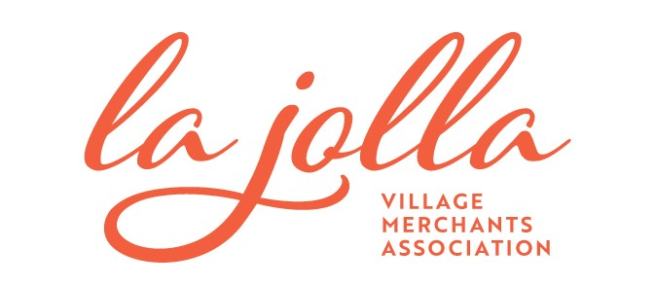
La Jollalty Card Merchant Participation Agreement
Thank you for taking part in the initial launch of the La Jollalty Card Show & Save Program. La Jollalty Card Offers will be listed on the lajollabythesea.com website and linked to your Business Listing. Please go to www.lajollabythesea.com to ensure that your online listing is current. You can add or update your business listing by going to lajollabythesea.com/merchant-resources/member-profile/
Business Information
Business Name: | Street Address:
Owner’s Name: | City/State/Zip:
Email: | Business Phone:
Website: | Cell Phone:

Discount Details - Minimum offer required to participate is 10% discount. Be generous and creative! Offer locals a deal or discount that is truly “exclusive.” Suggestions: Buy one get one, half free; Buy one, get one half off; Free appetizer or dessert; 25% off clearance/sale; 40% off one regular priced item.
Savings Offer(s): | Restrictions:

I, ________________________, agree to participate in the La Jollalty Card Show & Save Program and will
honor the offer(s) as stated above. I agree to display the “We Proudly Accept the La Jollalty Card” window decal which will be supplied to me by LJVMA. I can add or change the offer(s) seasonally or by written request. To terminate my involvement with the La Jollalty Card Program, I will submit a 30-day notice to the La Jolla Village Merchants Association. I understand that this is for the Show & Save Program only and does not include involvement in third part digital savings programs/online applications.

Price to Participate (LJVMA Members): Free
Price to Participate (Non-members): Please contact jodi@lajollabythesea.com
_______________________________ _______________________________
Signature Date

_______________________________ _______________________________
Print Name Title

