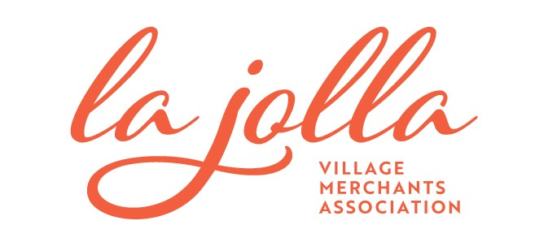
Follow Up Response to La Jolla Stall Count Request for Proposal:
The La Jolla Coastal Access and Parking Board has requested that all vendors be notified of the scoring matrix to be used in the award of the La Jolla Wayfinding and Stall Counting Request for Proposal originally submitted to the board on October 20th, 2020. All vendors shall be allowed to re-submit proposals if desired. The due date for any re-submissions if January 15th 2021.
Below you will find the scoring matrix to be used in the award of this Request for Proposal.
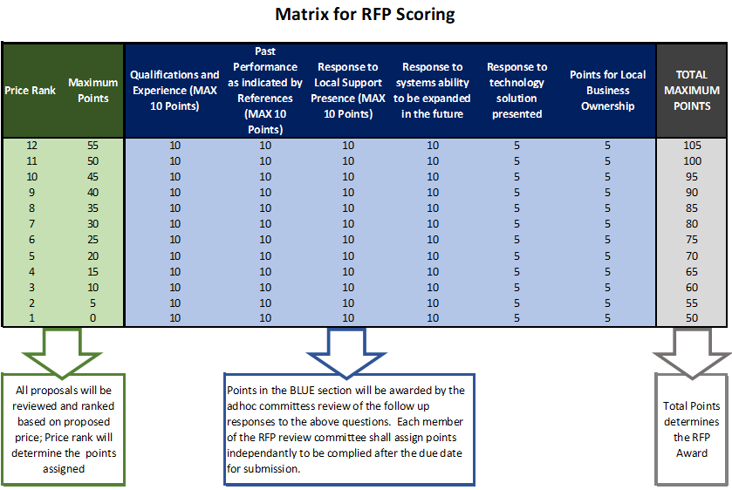

Pricing:
The La Jolla Project has a current budget of $110,000. Responses that do not fall under this limit for 24 months of operation will be awarded no points in the scoring matrix. Points shall be awarded based on the total cost of ownership for a 24-month period with 55 points awarded to the lowest cost solution and 0 points awarded to the highest cost option. Any ties in price shall be awarded the same number of points in the scoring matrix. Pricing submitted shall be considered the best and final price offer from each vendor. Should a vendor choose not the re-submit, the pricing in the original proposal shall be used.
Pricing re-submitted by any vendor must include the following table of costs
#1 – Total One Time Installation Costs
#2 = Any additional costs for Software Subscriptions
#3 – Any additional costs for maintenance of the equipment if not included in the One-Time Costs or the Software Subscription costs
Qualifications and experience:
This section shall include representative locations where the vendor as installed comparable equipment to provide real time occupancy data to variable message signs. Total of 10 points can be awarded at the board discretion based on the response this item. Should a vendor choose not to resubmit, information from their original proposal will be used to determine Qualifications and Experience.
Past Performance as indicated by references:
A total of 10 point may be award by providing at least 3 references of current operations. The board may contract these references at their discretion. Should a vendor choose not to resubmit, references from their original proposal will be used to determine the total points awarded.
Response to Local Support:
A maximum of 10 points may be awarded based on the vendors response to providing local support. The vendor shall respond as to the response time for equipment issues, available service vendors who can locally support the system, and if the repair of equipment is done by the bidding company, or by a third-party distributor. Should a vendor choose not to resubmit, information from their original proposal will be used to determine the total points awarded.
Response to the systems availability to be expanded in the future:
A maximum of 10 points can be awarded based on the system’s ability to be expanded in the future. The board is looking for the system to potentially supported to additional off-street facilities as well as the ability to add on-street single space capabilities in the future. Should a vendor choose not to resubmit, information from their original proposal will be used to determine the total points awarded.

Response to Technology Solution Presented:
There are various technology systems suitable for this project, please respond as to why the solution presented is the best technology for this project. Should a vendor choose not to resubmit, information from their original proposal will be used to determine the total points awarded.

Bonus Points for Local Ownership:
The La Jolla Coastal Access and Parking Board supports locally owned and operated companies, bonus points of up to 5 points shall be awarded for companies that are locally owned and operated with in the County of San Diego. Should a vendor choose not to resubmit, information from their original proposal will be used to determine the total points awarded.
Confidentiality
Confidential Information means any data or information contained in this document and any information provided by the La Jolla Merchants Association, La Jolla Coastal Access and Parking Board, ACE Parking LLC., or LAZ Parking. Disclosure of confidential information shall be limited to employees, representatives, consultants, and agents who have a need to know such Confidential Information. The Bidding Party shall use the Confidential Information solely in connection with providing a proposal to provide its products and services. All responses and proposals shall be considered the property of the La Jolla Village Merchants Association.
RFP Contact Information:
RFP Coordinator:
Jodi Rudick – Executive Director LJVMA
jodi@lajollabythesea.com
Work: 858.230.2725

Technical Questions:
Brad Elsass – VP, Strategic Initiatives
ACE Mobility Solutions
belsass@aceparking.com
858.454.8559

With thanks for your time, expertise, and timely follow-up –
Jodi Rudick, Executive Director

